
Term Project-Final Report
Website Chosen: Kıbrıs Gazetesi
Website Chosen: Kibris Gazetesi URL: https://kibrisgazetesi.com is one of the most popular news websites in the Turkish Republic of Northern Cyprus (TRNC). It provides news articles, multimedia content, and advertisements, making it an ideal candidate for a comprehensive quality assessment.
Project Members: ID: 21904531 | Name: Maaz Qureshi | Group: 2
ID: 22331350 | Name: Hasan Orkan | Group: 2
ID: 22002304 | Name: Samet Metehan Özyener | Group: 2
ID: 22701636 | Name: Saad Ahmad | Group: 1

Outline
Cover page.......................................................................................................................................................................................................................I
Introduction 3
Project Management Plan (timeline, work distribution, meetings) 3
Brief information about the website 4
Testing Strategy 4
Test plan 5
Testing Procedure We Are Going to Follow: 5
List of Tests Performed, the website's quality, and recommended improvements 6-17
Quality Assessment of the website 18-19
CONCLUSION 19
REFERENCES 20
GENAI USE in our Report 20

Introduction
We chose this website because it is one of the most popular reading newspapers in Northern Cyprus and has been active for a long period, thus having a history and an established digital infrastructure. This makes it an interesting candidate to investigate, as the high age and popularity of the language may ensure a substantial amount of data and potential insights. The objective of this assignment is to conduct a number of tests on the news website, Kibris GazeTesi, to assess the functionality, usability, reliability, security, and compatibility. "We're just going in with a specific testing regimen and procedure set and just trying to get to the bottom of any problems or shortcomings. As for what it is doing right and wrong, we'll also offer specific suggestions on how to raise the level of the site and make it more user-friendly.

Project Management Plan (timeline, work distribution, meetings)
- Work Distribution
- This table presents the distribution of work among group members.

Team Members | Roles | Tasks
Maaz Qureshi | Project Manager/Support Tester | Project management, Five testing, bug report, Test plan, Test strategies
Hasan Orkan | Main Tester | Five testing, Quality assessment
Saad Ahmed | Support Tester | Five testing, assists in testing
Samet Metehan Özyener | Report Writer/Support Tester | Five testing, assists in testing

2. Project Timeline & Milestones & meeting schedule
- This is our strategy for reaching milestones from the start of the project to the end. It lists the tasks we need to finish by certain dates. And in total, we've done 5 meetings; mostly, we do our meetings on Teams.
Task | Duration | Start Date | End Date
Selection of Website for Testing | 2 days | 05/03/2025 | 07/03/2025
Meeting 1 – Initial Planning | 1 hour | 07/03/2025 | 07/03/2025
Testing Strategies | 3 days | 07/03/2025 | 10/03/2025
Type of Testing | 5 days | 11/03/2025 | 16/03/2025
Meeting 2 – Strategy Review | 2 hour | 20/03/2025 | 20/03/2025
Selection of Testing Tools | 2 days | 25/03/2025 | 27/03/2025
Meeting 3 – Tool Discussion | 2 hour | 27/03/2025 | 27/03/2025
Testing for the Intermediate report | 4 days | 27/03/2025 | 30/03/2025
Preparation for Presentation | 2 days | 30/03/2025 | 02/04/2025
Intermediate Upload | 8 days | 02/04/2025 | 10/04/2025
Remaining Testing | 12 days | 01/05/2025 | 12/05/2025
Reviewing the test result | 2 hour | 12/05/2025 | 16/05/2025
Discussion on Website Quality | 4 days | 16/05/2025 | 20/05/2025
Final Presentation | 4 days | 21/05/2025 | 25/05/2025
Meeting 5 – Final Review | 3 hour | 02/05/2025 | 02/05/2025
Final Report Submission | 1 month | 01/05/2025 | 06/05/2025

Brief information about the website
Kibris GazeTesi is a newspaper that has been officially published since 1989 in Northern Cyprus. Now, it is on digital platforms where we can check daily news about the TRNC, Turkey, the world, and Greek news, articles, sports topics, etc. Also, other than news, we can access their Live TV channel and radio through their website. The site is organized into different sections to make the header topics more accessible, such as:
- Homepage:
- In the task bar’s home page, you can see daily popular short news, some articles by authors, some short videos from their YouTube channel, daily exchange rates, and the Cyprus league scoreboard. Also, you can click the specified topic in the taskbar to see all the provided things.
- Section and Categories
- TRNC: ALL daily news about the TRNC provided by their newspaper
- Greek press: Highlights of Greek news
- World: International important news
- Economy: Financial news
- Sports: Sports news in Cyprus and important events in the world
- Interviews: Interviews about important events in the TRNC
- All news: Section where we can see all the news
- Authors: Columns and articles by authors
- Deaths: Obituaries and announcements
- Search Functionality
- The website has a search bar where a user can find articles and news by entering keywords or normal words.
- User Interaction
- Users can engage with content by commenting in the comment section and sharing it with their friends or on social media.
- Accessibility Features
- The user can change and resize the text size manually
- The user can change the reading mode to dark or light mode
- The user can easily adjust browser size without affecting layout or readability

Testing Strategy
To test this website, we are going to use the black box testing technique since we don’t have access to the code. Black box testing focuses on externally seen behaviors without access to the main code. Black box testing focuses on functionality, usability, performance, and security. With testing, we will use this approach to assess how well it meets industry standards.
We will use both manual and no-code automated testing tools to assess various critical aspects of the website. These tools will help us in evaluating the website, including how effectively it works, how secure it is, and whether it meets accessibility and usability criteria.
To assess the website's quality, we will use web testing tools. The evaluation will be based on plenty of information collected by these testing tools, which will analyze important performance indicators across multiple quality aspects. The results will provide practical knowledge about the strengths, weaknesses, and areas of this website and how well this website is.

Test plan
To test this website within the specified duration, some tests were performed during the intermediate report, and the execution of these tests continues to encompass and examine more details. We did a total of four tests in our intermediate report, while the remaining will be included in the final report. As I mentioned, black box testing will be performed since we do not have access to any of the source code. In our Final report, we will conduct about 14 tests, with our previous tests made in the intermediate report, totaling 18.
Here are the tests we performed for the final report:
- Website monitoring: Conducts checks on the website’s uptime and visibility for user accessibility right around the clock.
- HTML & CSS Validation: Checks the website's HTML and CSS code with web standards to ensure correct display across different browsers.
- Broken Link Testing- Review of a site to locate broken links to address what is not working and to ensure a smoother user experience.
- Security and Vulnerability Testing: Scans for missing security headers, weak configuration settings, and multiple other vulnerabilities that could be targeted to cause damage (including but not limited to: XSS, clickjacking).
- SEO Testing: Evaluates meta tags, keywords, page speed, and the arrangement of different portions of the website to boost the ranking.
- SSL/TLS Security: Checks if the website has an active SSL certificate and if the website uses low encryption protocols for data transfer.
- Cookie Testing: Testing the cookies' attributes relating to their security, such as HTTP only and Secure, and compliance with privacy laws such as GDPR.
- DNS & Network: Examines the strategy and the domain name for speeding up protocols and response time, and ensuring the name resolution is both fast and reliable.
- Third-Party Script Testing: Checks the reliability and effectiveness of third-party scripts (e.g., ads, analytics) to avoid loading issues or page delays.
- Caching & Header Testing: Examines caching configurations alongside HTTP response headers for faster loading times and reduced bandwidth expenditure.
- Malware & Threat Testing: Check the website for infections, harmful code, and blacklisting to maintain a secure website image.
- A/B Testing: Checking user interaction with various layouts or content of a webpage to identify the most favorable design.
- Content Testing: Verifies quality communication and user engagement by assessing spelling, content, format consistency, and overall readability
- Usability testing is a tool for improving the performance, quality, and correctness of the website

Testing Procedure We Are Going to Follow:

Choice of Testing Tools: Find out and select suitable testing tools based on all the different testing types.

Execution of Tests: With the tools selected, systematically conduct the tests:

Result Evaluation: After the tests are done, review the gathered information to determine insights and the significance of the result (accuracy and precision). Analyze and compare the results to benchmarks or industry baselines for performance evaluation.

Bug report: If we find any bugs during the testing of the website, we will provide

Recommendations for Improvement: Suggestions for ways in which the feature could be improved to enhance the safety or ease of use, and performance of the software

List of Tests Performed, the website's quality, and recommended improvements.

HTML/CSS validation Testing:
Tools used: Nu Html Checker (url: https://validator.w3.org/nu/?doc=https%3A%2F%2Fkibrisgazetesi.com%2F)
Execution of Tests: The test was conducted by entering the website’s URL into the Nu Html Checker, and the tool is an ongoing experiment in better HTML checking, and its behavior remains subject to change
Result Evaluation:
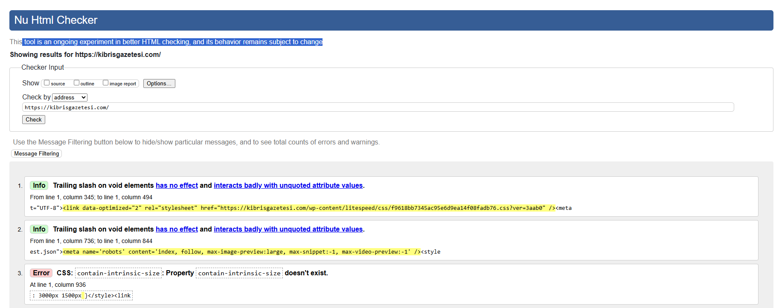
The result that we get from the problem we see in this testing is that we find several issues that need to be fixed. There were 22 missing alt attributes, which can negatively affect both SEO and accessibility. And we found 58 miswritten void elements that may lead to browser compatibility problems in the CSS section, We detected 2 syntax errors, some missing values, and 4 duplicate IDs, which is a risk for JavaScript-driven components and may cause unexpected behavior or problems to the website. And the total execution time is 746 milliseconds.
Bug report: Here we find some CSS bugs and some script bugs.
- Improper style element placement: <style> elements found in invalid locations (body/content areas); it should be in the head part
- <style> elements as children of <div> elements (invalid context) also Unnecessary type="text/css" on style elements
- Invalid CSS at line 1101: left:50px important; (missing ! before important)
- Invalid type "speculationrules" at line 1136 (missing subtype)
Recommendation for improvement: So, the developer of this website should fix the CSS and HTML bugs to increase the performance of this website and avoid any problems for users of this website.

Broken Link Testing
Tools used: dead link checker (URL: https://www.deadlinkchecker.com/website-dead-link-checker.asp)
Execution of Tests: A Broken Link Tool is a utility that helps identify hyperlinks on a website that no longer work, also known as "dead" or "broken" links
Result Evaluation:
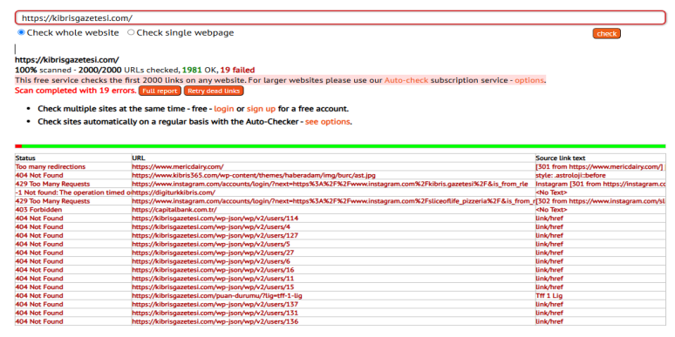
The result we got from the broken link testing showed 19 failed URLs that are not working from 2000 URL tests, however. These included several 404 Not Found errors, indicating that the destination pages no longer exist or the links are broken. We also find 403 Forbidden errors, showing that the server is refusing access to certain resources. Also, there were too many redirection URLs caught in a redirection loop, likely due to a slow or unavailable external server. These problems can affect user experience. When using the website, they may face problems, so developers should fix these problems.
Bug report: These are the types of bugs we see in testing the broken testing.
- Too many redirections. This is the URL: https://www.mericdairy.com/ site cannot be accessed
- 404 Not Found https://www.kibris365.com/wp-content/themes/haberadam/img/burc/ast.jpg image files not founded
- 429 Too Many Requests: Multiple Instagram login links. Users may face delays or access issues
Recommendation for improvement: So, the developer of this website should either delete or fix these links on the website

- Usability Testing
Tools used: Page Speed Insights (URL: https://pagespeed.web.dev/)
Execution of Tests: Usability Testing— a tool for improving the performance, quality, and correctness of the website, and Goal: Improve the user experience, accessibility, and correctness of the interface.
Result Evaluation:

Desktop Results Summary
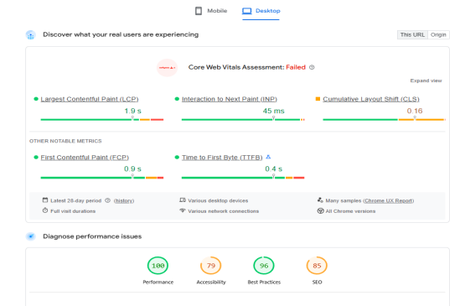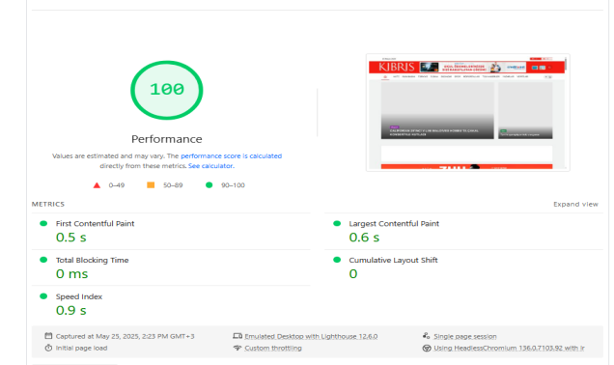

Mobile Results Summary
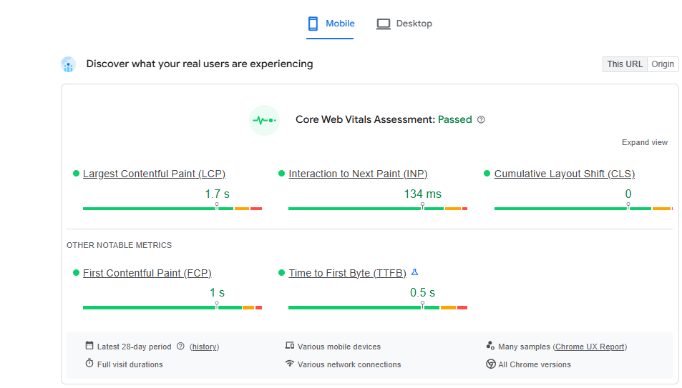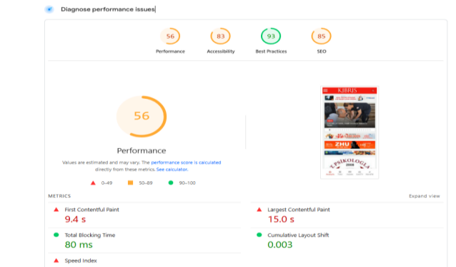
In here, we have done an overall test. We have done a whole system testing together to check performance issues, accessibility, and SEO all together for desktop Core Web Vitals. Assessment failed; it is a Google performance evaluation of a web page's user experience, specifically focusing on loading speed, interactivity, and visual stability. So, in performance, it was really good. It is a category there, so no problem. Accessibility result: it is 79, and the primary reason is that elements do not have a title, and background and foreground colors do not have a sufficient contrast ratio. For the SEO testing, it is better; it is 85 for the reason that it is less because image elements do not have [alt] attributes
For mobile Core Web Vitals Assessment: Passed, but compare the desktop mobile performance, which is less at 56; also for accessibility, 83; and for SEO, it is the same. The reason the performance is less is that First Contentful Paint is 8.3, and the speed index is 8.4, and there is too much unused JavaScript and also unused CSS.
Bug report: Here is overall of this bug we have found.
- Missing <meta name="description">
- Missing alt attributes on images
- <iframe> elements lack title attributes
Recommendation for improvement: Therefore, the developer should address accessibility issues in both the desktop and mobile versions. Additionally, they should improve phone performance by removing unused coding parts.

Caching & Header Testing
Tools used: REDbot (URL: https://kibrisgazetesi.com/)
Execution of Tests: Caching & Header Testing is the process of analyzing how a website's server responds to browsers and other clients in terms of data storage (caching) and HTTP header settings.
Result Evaluation:
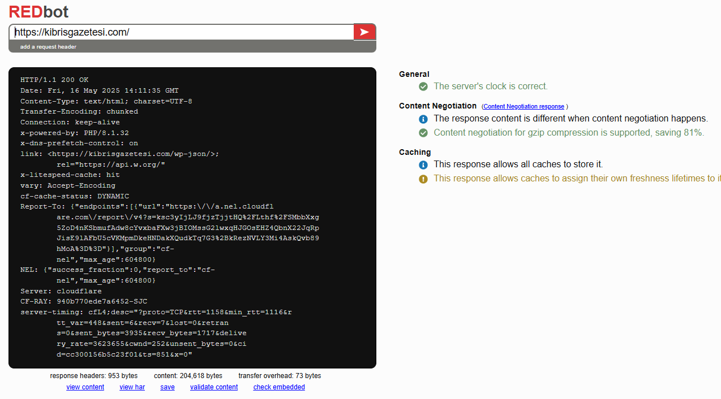
In Caching & Header Testing, as you can see from the result, generally, the server's clock is correct. And the content negotiation part: when content negotiation is used, the response content typically shouldn't change between negotiated and non-negotiated responses either. Content negotiation for gzip compression is supported, saving 81%. The caching part of the response also allows all caches to store it. This response allows caches to assign their freshness lifetimes to it.
Recommendations
To improve caching efficiency and protocol compliance: Set Valid Expires Header: Use a proper HTTP-date or remove the Expires header if Cache-Control is present.
Include Validators: Add E Tag or Last-Modified headers to enable conditional requests and reduce bandwidth usage.

SEO Testing
Tools used: SEO Site Checkup (online)
Execution of Tests: An SEO test is performed by checking a given URL on the SEO Checkup, which assesses the search engine optimization of a website. It analyzes the performance of certain criteria such as meta tags, keywords, titles, and headings.
Result Evaluation:
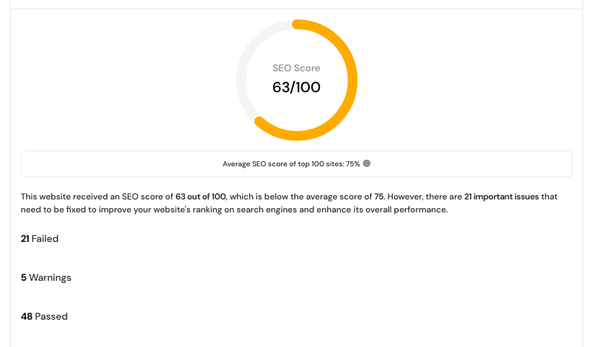

In the test, we have SEO in, so the result it gave us was 63/100, which is quite below average. Also, 21 issues failed, 5 warnings, and 48 passed. So, of the high-priority issues identified, we find a Missing Meta Description: The homepage lacks a meta description tag. Largest Contentful Paint (LCP): Measured at 11.79 seconds (Google recommends < 2.5 s). Keyword Usage: Common keywords are not well distributed in the title, heading, or meta tags. Too Many H2 Tags: More than 15 H2 elements, which may reduce search clarity. Render-Blocking Resources: Slows down page load time. URL Format: Uses parameters or underscores, which are less SEO-friendly. Other issues we find are that some images lack alt text. Responsive image sizing and aspect ratios are inconsistent. Inline CSS is used, which isn’t ideal for SEO. Some of the good things about HTTPS and SSL certificates are properly configured. robots.txt and sitemap.xml are present. No JavaScript or mixed-content errors were found. The site is mobile responsive, uses Open Graph/Twitter meta tags, and supports structured data.
Recommendations for Improvement:
Finding actionable methods to improve SEO and website speed through eliminating render-blocking elements, optimizing images, and adjusting the placement of keywords in titles, headings, and meta tags. Moreover, ensure that all images have relevant alt descriptions, control the use of heading elements with the header tags, and resize images responsively to reduce the website’s downloading time. Lastly, avoid inline CSS as well as use hyphens in place of underscores for the URL to better structure and enhance the website that is tailored for search engines and users alike.

Security & Vulnerability Testing
Tools used: UpGuard Cyber Security Ratings (https://www.upguard.com)
Execution of Tests: A full security evaluation, which included assessing the website security, email security, DNS settings, encryption levels of SSL TLS, vulnerability management, and many other factors, was conducted on the primary domain kibrisgazetesi.com to find any weaknesses within its infrastructure.
Result Evaluation:
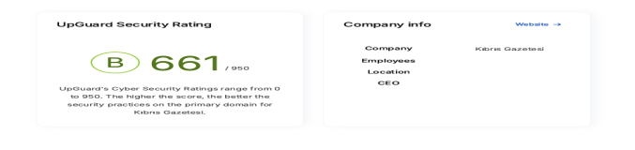
So in the test, we analyze it, and the result we get from it is Overall Security Rating B (661/950)—Indicates moderate security practices with room for improvement. In the Website Security, 1 X-Powered-By header exposed was 1 CSP not implemented with 1 X-Content-Type-Options not set to "nosniff" and 2 server information headers not exposed (positive finding). Email Security: DMARC, SPF, and DKIM are properly configured (positive finding). DNS Security: DNSSEC is not enabled. Domain deletion/update protections are not enabled. In the Encryption, HSTS is not enforced, and insecure SSL/TLS versions are supported. Weak cipher suites detected in TLS 1.2 Vulnerability Management No critical vulnerabilities (Heartbleed, POODLE, FREAK, Logjam) were found (positive finding).
Recommendations for Improvement:
To increase the strength and security of a website, remove or change the server headers to prevent ever giving away sensitive information, apply stricter policies regarding content scripted into the website (CSP) to help limit cross-site scripting, and add the ‘Sniffer’ header to guard against MIME-type attacks. Also, enable DNS Security Extensions (DNSSEC) to strengthen the domain and protect it from attackers, enforce domain locks with clientDeleteProhibited and clientUpdateProhibited flags, and enable HTTP Strict Transport Security (HSTS) along with subdomain inclusion directives. Other adjustments include shutting off old protocols in favor of TLS 1.2 or above and removing weak RC4 and DES ciphers to further strengthen encryption.

SSL/TLS Testing
Tool Used: Internal SSL and Server Response Testing
Execution of Tests: Multiple server IPs were tested for readiness and SSL configuration.
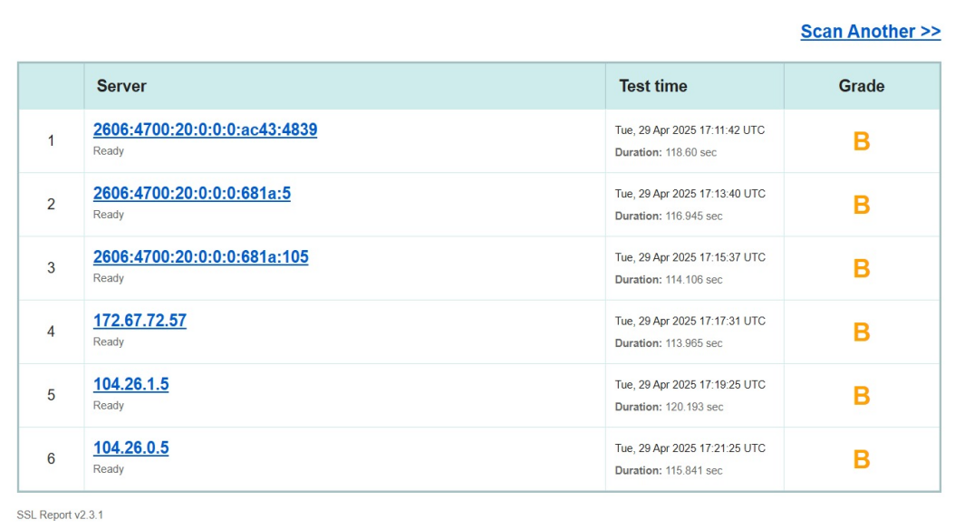
Server IPs Tested
- 2606:4700:20::ac43:4839(118.60s)
- 2606:4700:20::681a:5 (116.945s)
- 2606:4700:20::681a:105 (114.106s)
- 172.67.72.57(113.965)
- 104.26.1.5(120.193)
- 104.26.0.5(115.841s)
Average response time: ~117 seconds
SSL Report Summary
- SSL Certificate Valid & Trusted
- Hostname matches certificate
- No revoked certificates detected
- Strong encryption (SHA-256, 2048+ bit key)
- SSL does not expire within 20 days
Recommendations:
Renewing the SSL certificate before expiration (current validity < 398 days) and disabling legacy SSL/TLS protocols for stronger security would be more than enough.

Website Monitoring
Tool Used: Pingdom (URL: https://tools.pingdom.com/#65cb11306b000000 )
Execution of Tests: Tracks the uptime and performance of overall of the website
Result Evaluation:
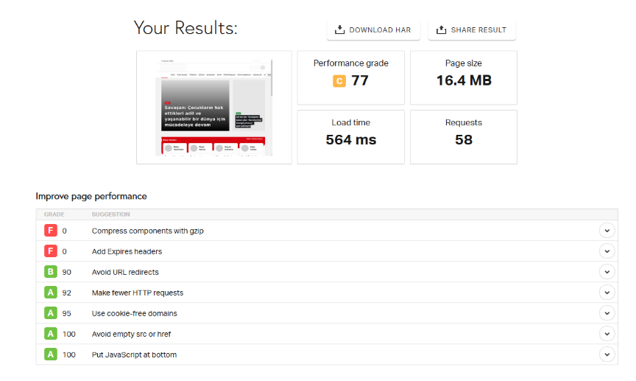
The analysis conducted during testing shows that the performance grade is 77, placing it in the C category. The page size is 16.5 MB, the load time is 545 ms, and there were 58 requests; the response was acceptable. The website performs well but is not exceptionally fast; additionally, Web pages are becoming increasingly complex with more scripts, style sheets, images, and Flash on them. A first-time visit to a page may require several HTTP requests to load all the components. Web pages are becoming increasingly complex with more scripts, style sheets, images, and Flash on them. A first-time visit to a page may require several HTTP requests to load all the components. Also, compressing components with gzip fails here with the Expires header.
Recommendations: So, the developer of the website should use modern formats like WebP and AVIF. For the compressed images, use modern tools like TinyPNG and ImageOptim, and to minimize HTTP requests, combine CSS and JS files, and reduce the number of external fonts and libraries ..

A/B Testing
Tool Used: Simulated A/B test (Manual analysis with VWO A/B Test Calculator along with fabricated data)
Execution of Tests: The website ‘kibrisgazetesi.com’ served as the stage for our simulated A/B test. The experiment involved two headline variations for the leading news article. It was aimed at finding what style gets the most clicks. This was an interaction test through commentary.
Result Evaluation: Variant B showed a simulated 62.5% increase in click-throughs compared to Variant A. This suggests that emotionally engaging headlines may be more effective in attracting readers.
Recommendations:
When creating leading headlines, use phrases that appeal to and evoke curiosity or emotional responses to increase click-throughs. Perform live A/B tests for actual users on the site with numerous tools like VWO or Optimizely, or open-source ones such as GrowthBook. Use Google Analytics (GA4) for long-term tracking of user interactions and monitoring to see if any changes are being registered over time. Consider experimenting with other sections of the homepage. Some specifics are images, action phrases, or the arrangement of items."

Content Testing
Tool Used: Power Mapper (URL: https://www.powermapper.com/ )
Execution of Tests: The testing will verify media and text accuracy of the website, the errors, and compatibility
Result Evaluation:
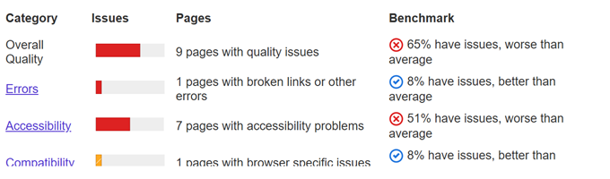
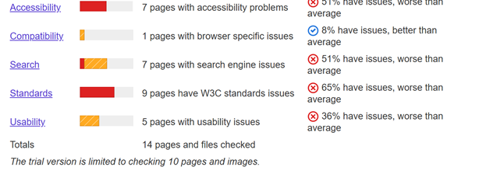
The result we get from these context tests, 9 pages, has quality issues. 65% of pages have issues, which is worse than average. The red bar indicates a high severity of issues affecting general quality. Only 1 page has broken links or other errors. 8% of pages have issues here, which is better than average — this is a strong point. In the Accessibility part, 7 pages have accessibility problems. 51% issue rate, which is worse than average. This suggests the site might not be sufficiently accessible to users with disabilities. The Compatibility1 page has browser-specific issues. 8% issue rate — better than average, so no major concern here. In the search engine (SEO), 7 pages have search engine-related issues. 51% issue rate — worse than average. This indicates poor search engine optimization, which could hurt visibility. The Standards (W3C Compliance) 9 pages have W3C standards violations. 65% issue rate — this is critical and impacts technical robustness. Also, 5 pages have usability issues. 36% issue rate — still worse than average, though better than some other categories.
Recommendations:
So, several changes have come up that could boost the quality of the website based on what we find during the content testing. Firstly, it is important to tidy up the material—think correctness, clarity, and structure—because quite a few pages are running into general content problems.
And getting this over half of the pages have accessibility issues. That points to the need for us to stick to accessibility principles. We should work on enhancing contrast and adding those missing labels, too.
Now, when it comes to SEO, we need to tackle a few things, like fixing incorrect tag usage and filling in those missing meta descriptions. And let’s not forget about the W3C validation issues; sorting those out will help with the site’s technical resilience.
To keep things feeling consistent for users across different platforms, we should also take a good look at usability concerns that are messing with navigation and layout. And, honestly, it wouldn’t hurt to keep an eye on browser compatibility regularly.

- Cookie Testing
Selection of the tools used: Cookie Bot https://www.cookiebot.com/
Execution of Tests: The test was executed by scanning the website URL to check and validate cookie functionality. Check if your website’s use of cookies and online tracking is compliant with GDPR and the ePrivacy Directive (ePR).
Result Evaluation:
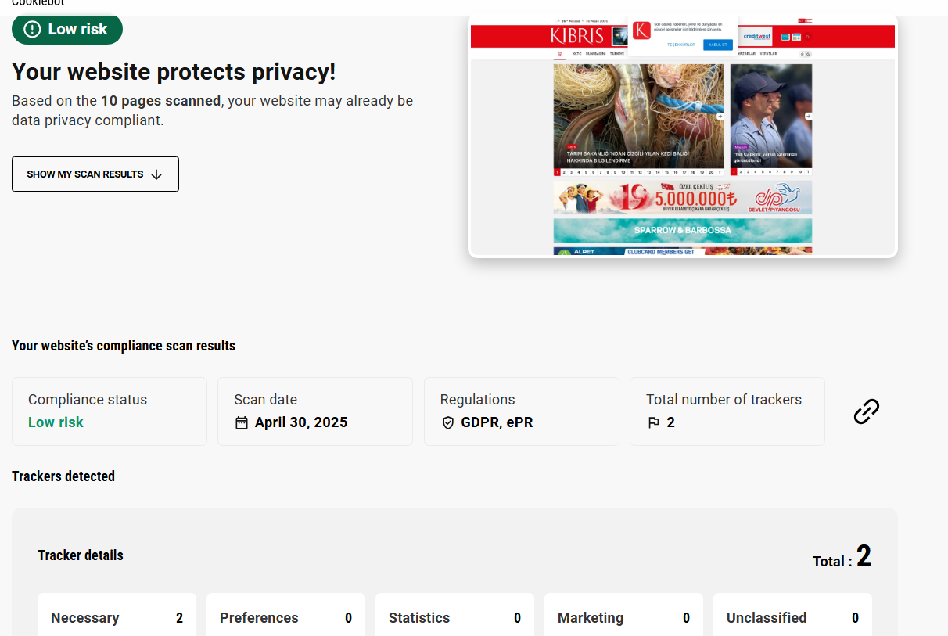
Positive Results:
- Low Risk, Complies with Regulations GDPR,ePR
- Cookie Banner appears
2 Trackers Detected:
- Name: __cf_bm
- Provider: onesignal.com
- Category: Necessary
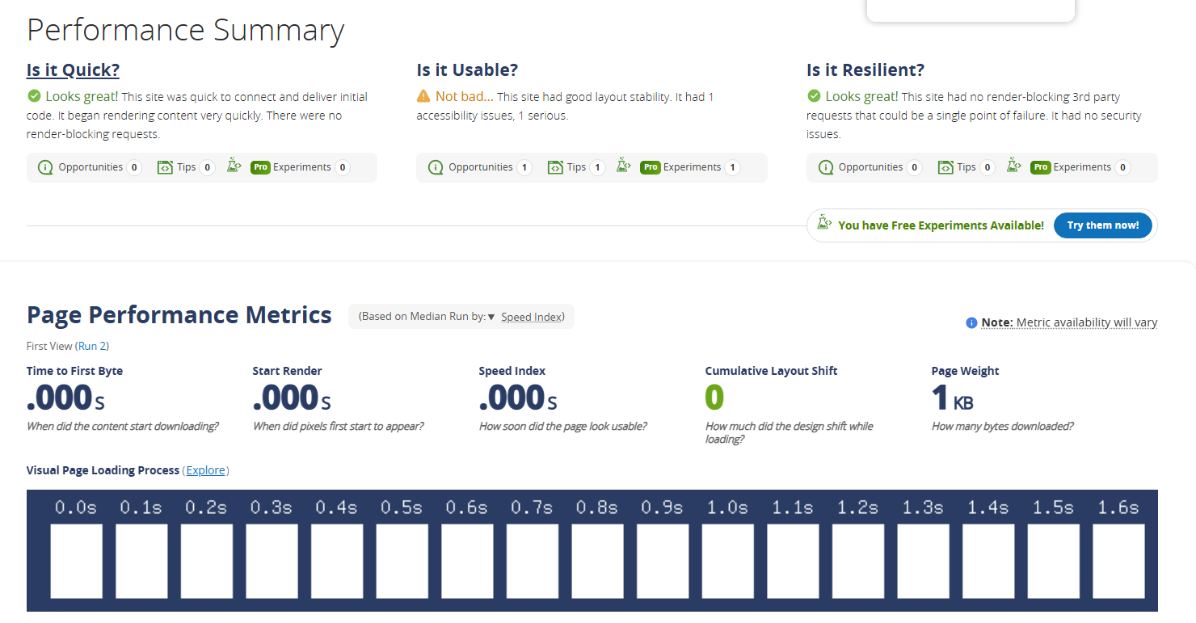
Positives:
- Render Good, No security issues
Negatives:
- 1 Serious accessibility issue
- Cookies load before consent
No Option to withdraw consent
Bugs:
- Third-party cookies load without consent: Critical Severity, Third-party cookies were seen loading before the user gave consent.
- No Reject Button: High Severity, Cookie banner only provides 'Accept' option. Under GDPR, rejection must be as easy as acceptance.
- No Consent Withdrawal Option: High Severity, User cannot withdraw or change their cookie consent after initial selection.
- Easy to change cookie page: Low Severity, Site lacks a dedicated page listing all cookies in use with purpose & duration.
Recommendations:
- Use script blocking with Cookie bot or a similar tool until consent is given
- Add a visible and equally accessible 'Reject' or 'Deny' button.
- Include a persistent banner or link to reopen consent preferences (e.g., footer link).
- Add a cookie settings change page linked from a banner or a privacy policy

- DNS & Network Testing
Selection of the tools used: MX Toolbox https://mxtoolbox.com/
Execution of Tests: A comprehensive scan was performed on the primary domain of kibrisgazetesi.com, evaluating DNS & Network testing Purpose: Perform DNS look ups, blacklist checks, MX record validation, and identify potential network-related issues for a domain.

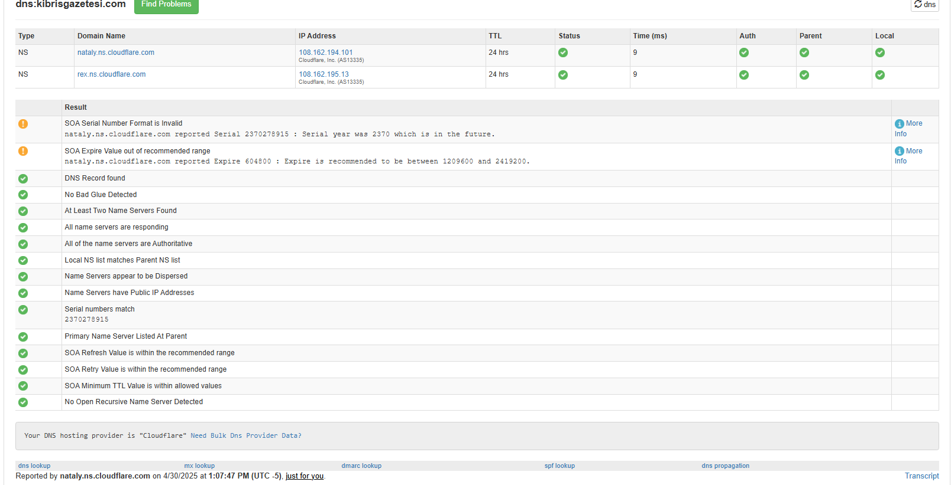
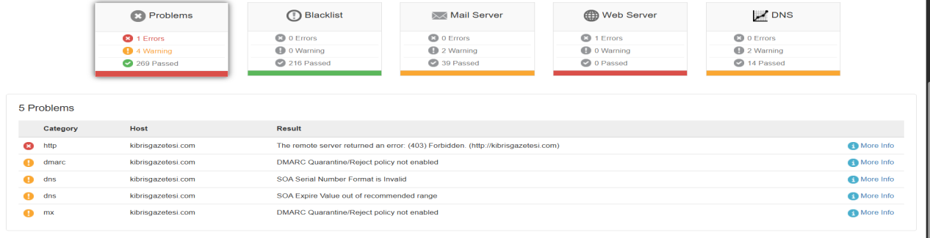

Problems:
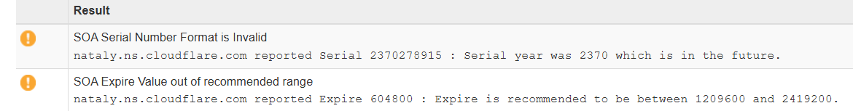

Positives:
Not listed in Major Blacklists like spam or malware
Uses Cloudflare – ensures DDoS protection, fast DNS resolution, and caching.
Bugs:
- Missing SPF Record: High Severity, No Sender Policy Framework (SPF) record present for domain emails.
- No DKIM Detected: High Severity, Domain-keys Identified Mail (DKIM) signature not found.
- No DMARC Record Found: Medium Severity, DMARC (Domain-based Message Authentication) record is not set.
- No IPv6 DNS Record: Low Severity, No record found in DNS for AAAA (IPv6).
Recommendations:
- Add a valid SPF record, which will reduce the risk of email spoofing.
- Implement DKIM to ensure email integrity and authentication.
- Add a DMARC policy to instruct mail servers how to handle unauthenticated emails.

- Third-Party Script Testing
Tool Used: Secure Site Check https://sitecheck.sucuri.net
Execution of Tests: checks the website for known malware, viruses, blacklisting status
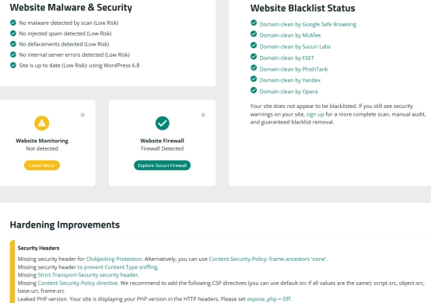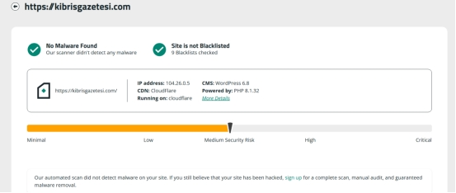

Positives:
No malware found, site is not blacklisted
Bugs:
- Missing Click-jacking Protection Header: Medium Severity, X-Frame-Options header is missing, clickjacking attacks possible.
- Missing Content-Type Sniffing Prevention: Medium Severity, X-Content-Type-Options header is missing, which can allow browsers to sniff MIME types.
- Missing Strict-Transport-Security Header: Medium Severity, HTTP Strict Transport Security (HSTS) header is missing, reducing HTTPS protection.
Recommendation:
- Add 'X-Frame-Options: SAMEORIGIN' or use the Content-Security-Policy frame-ancestors directive.
- Add 'X-Content-Type-Options: nosniff' to your HTTP response headers.
- Add 'Strict-Transport-Security' header with an appropriate max-age directive to enforce secure connections.

- Malware & Threat Detection
Tool Used: Tools: Norton Safe Web https://safeweb.norton.com/
Execution of Tests:
- Scans for malicious content

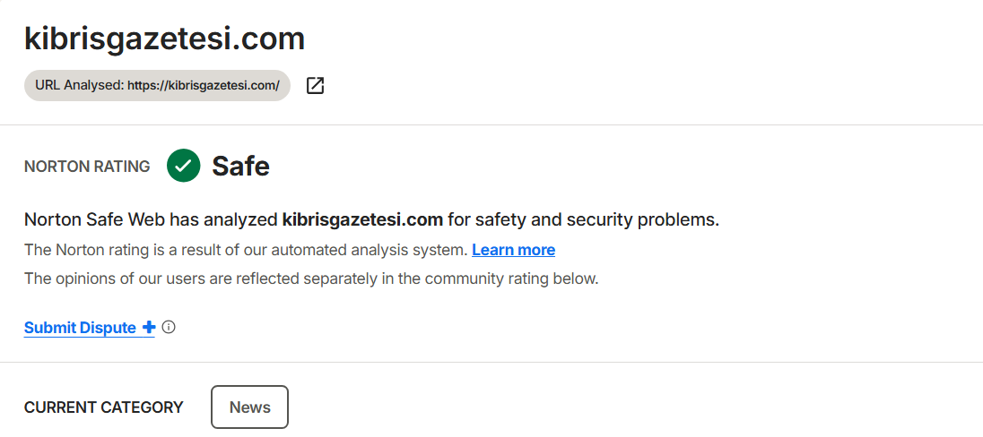
Norton Rating:
Safe

Quality Assessment of the website
For quality assessment of the website, we will evaluate the results that we get from tools and from error bugs. To access this with success, we will firstly get all grades, then standardize them out of 10 to compare them fairly, scaled. In the end, to get avg grade for this assessment, we will add all standardized grades and divide by the number of tests.
We will use A-E grades in this system: A=10, B=8, C=6, D=4, and E=2. On the other hand, if the scores are out of 100, we can divide them by 10 to standardize the process, or if the grade i is out of 5, we will multiply by 2.
TEST NAME | STANDARDIZED SCORES
Performance Testing | 10
Accessibility Testing | 6
Cross-Browser Testing | 8
Mobile Responsiveness Testing | 10
Usability Testing | 8
SEO Testing | 6
Security & Vulnerability Testing | 7
SSL/TLS Testing | 8
Website Monitoring | 9
HTML & CSS Validation | 5
Broken List Testing | 8
Cookie Testing | 7
DNS & Network Testing | 7
Third-Party Script Testing | 8
Caching & Header Testing | 9
Malware & Threat Detection Testing | 10
A/B Testing | 9
Content Testing | 5
10+6+8+10+8+6+7+8+9+5+8+7+7+8+9+10+9+5= 140
140/18=7.77
Website Quality Benchmark Comparison (kibrisgazetesi.com vs Industry Standards)
TEST NAME | Our Score | Benchmark | Gap analysis
Performance Testing | 10 | 9-10 | It is much the industry standards
Accessibility Testing | 6 | 8-10 | Critical gap - 27 errors/41 contrast issues found
Cross-Browser Testing | 8 | 9-10 | Minor gap - Minor rendering inconsistencies
Mobile Responsiveness Testing | 10 | 9-10 | Meets the standard
Usability Testing | 8 | 9-10 | Slight navigational inconsistencies on deep pages.
SEO Testing | 6 | 8-10 | Significant gap - 11.79s LCP, missing meta descriptions
Security & Vulnerability Testing | 7 | 9-10 | High risk - Missing CSP/HSTS headers
SSL/TLS Testing | 8 | 9-10 | Legacy protocols not fully disabled; handshake slightly above ideal.
Website Monitoring | 9 | 9-10 | Minor gap - 77 performance grade
HTML & CSS Validation | 5 | 8-10 | Critical gap - 22 missing alt tags, 58 void elements
Broken List Testing | 8 | 9-10 | Gaps: 19 errors in the link
Cookie Testing | 7 | 9-10 | Gap: No “Reject” button, no preference recall.
DNS & Network Testing | 7 | 9-10 | Gap: Missing email auth records, no IPv6, no DNSSEC.
Third-Party Script Testing | 8 | 9-10 | Some scripts still render-block.
Caching & Header Testing | 9 | 9-10 | The Expires header is missing on a few assets
Malware & Threat Detection Testing | 10 | 9-10 | Meets the standard
A/B Testing | 9 | 9-10 | Simulated rather than live
Content Testing | 5 | 9-10 | Critical gap - 65% of pages have issues

Overall Average

Kıbrıs Gazetesi website : 7.77 / 10

Industry “Good” Standard: 8.5 – 9.5 / 10
The website achieved an average score of 7.77 out of 10, indicating fair quality, but it is not quite at level high standard, compared to the industry standard.

It is really recommended for the developer of the website to focus on this part.

Improving accessibility (e.g., screen reader support, contrast ratios)

Optimizing SEO elements such as meta tags and alt texts

Validating and cleaning HTML/CSS code for better structure

Enhancing content quality by correcting grammar, tone, and relevance

Cookie: Add “Reject” button, consent recall, block scripts pre-consent.
By improving these weaker areas, the website could go from an average of 7.0 to 8.5+, meeting or beyond the standards set by professional benchmarks for modern, user-centered websites.

CONCLUSION

During this project, we completed a multi-faceted quality assessment of the Kibris Gazetesi website. Our scope of testing included: performance, accessibility, mobile usability, cross-browser functionality, SEO, security, broken link scanning, cookie handling, SSL/TLS setup, and content verification.

The web page performed well in groups, including mobile responsiveness, cross-browser compatibility, and loading speed. These parts show an excellent front-end and improve the user experience generally.

However, our testing result shows several serious problems. Like, we find some problems in the Accessibility testing, discovered missing form labels, missing image alt attributes, and poor color contrast, all of which present difficulties for users who rely on assistive devices. Also, we find missing security headers while doing the security testing, outdated SSL protocols, broken links, and bad SEO elements like missing meta descriptions and keyword misuse.

While the website is good and is designed reasonably well, there is a need for improvement. Addressing these problems will not only improve usability and security but also increase accessibility and search engine effectiveness. Implementing industry-standard best practices in these areas is strongly recommended for raising the overall quality and reach of the website.

REFERENCES
- GTmetrix (https://gtmetrix.com/)
- WAVE (https://wave.webaim.org/ ).
- UpGuard ( https://www.upguard.com/)
- Lambda Test (https://www.lambdatest.com/).
- Responsive Viewer (https://try.responsiveviewer.org/)
- EO Site Checkup (https://seositecheckup.com/ )
- Dead Link Checker (https://www.deadlinkchecker.com/)
- SSL Labs (https://www.ssllabs.com/ssltest/ )
- CookieBot (https://www.cookiebot.com/)
- WebPageTest (https://www.webpagetest.org/)
- MXToolbox https://mxtoolbox.com/)
- Sucuri SiteCheck https://sitecheck.sucuri.net/ )
- RedBot https://redbot.org/ )
- Google Lighthouse - https://pagespeed.web.dev/ )
- Norton Safe Web https://safeweb.norton.com/ )
- W3C Validatore https://validator.w3.org/ )
- Pingdom Tools: https://tools.pingdom.com/ )
- PowerMapperr https://www.powermapper.com/ )
- Google Optimize)

GENAI USE in our Report
We utilized AI and Deep Seek, but we completed most of the task independently. However, in some parts of the testing, we were unsure about what to do or what these problems were. We requested a thorough analysis of this testing from Deep Seek. What is the meaning of this result? What does this type of error mean?

So we got 79 out of 100, and the tool we used is https://www.hipdf.com/app/ai-detector-result.

